# Unit 7: Constructing Normalised Tables and Database Build

In this unit we:

* Learned how to take a flat file and turn it into a clean, normalised database structure.
* Built a relational database and tested how well it works in practice.
* Figured out which data items depend on each other and how they’re connected.
* Looked at any limitations or restrictions that come with the dataset and how it can be used.
* Identified which data attributes are actually important and necessary for working with that dataset.

## **Normalisation Task**

We were given a table with data in un-normalised form and were requested to normalise the data to 3rd form (3NF), showing each process, from 1NF to 3NF.

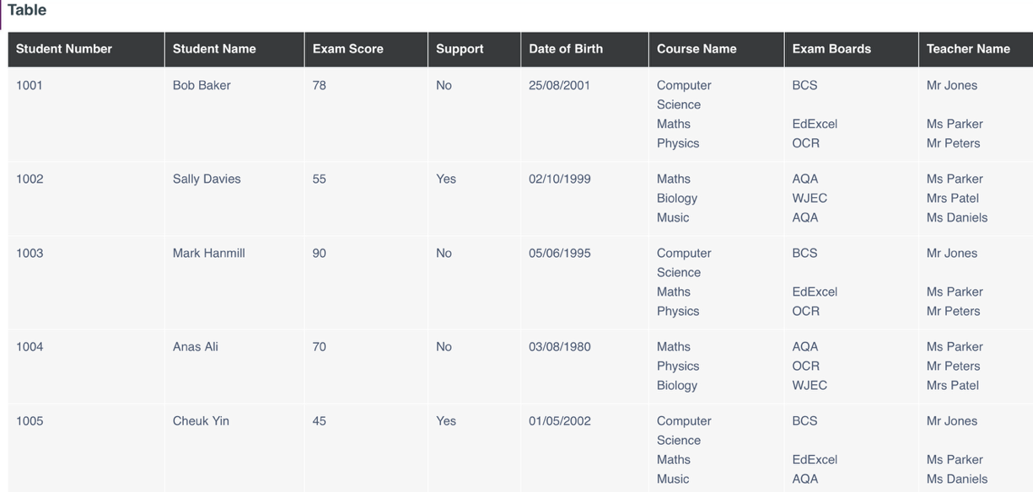

**Normalisation Process**

1. First Normal Form(1NF)

* This is achieved when every column is atomic and each row is unique(Rob & Coronel, 2007), as seen below.
* I put every student’s details across rows so each record is unique and complete.

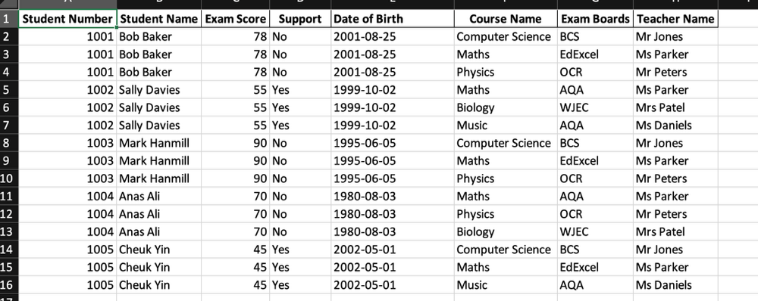

1. Second Normal Form(2NF)

* A relation is in 2NF if:
  + It is already in 1NF
  + All non-key attributes are fully functionally dependent on the whole of a composite primary key
* I separated student-specific data, course-specific data and exam data. This step removed partial dependencies(Elmasri & Navathe, 2015)

Student Table

Course Table

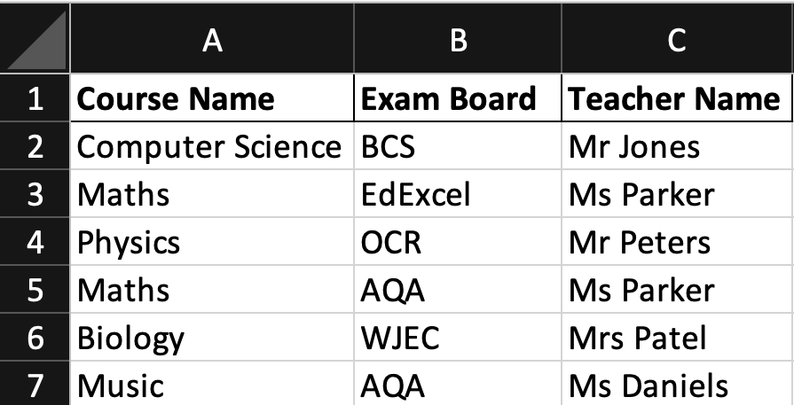

Exam Table

1. Third Normal Form(3NF)

* A table is in 3NF if:
  + It is already in 2NF
  + All non-key attributes are only dependent on the primary key and not on any other non-key attribute (no transitive dependencies).
* I retained the **Students Table**,**Courses Table**, and**Exams Table**from 2NF
* To eliminate transitive dependencies,
  + I introduced a unique Course ID in the Courses Table, making it the primary key
  + Replaced the composite identifier in the Exam table with the Course ID as the foreign key

Student Table

Course Table

Exam Table

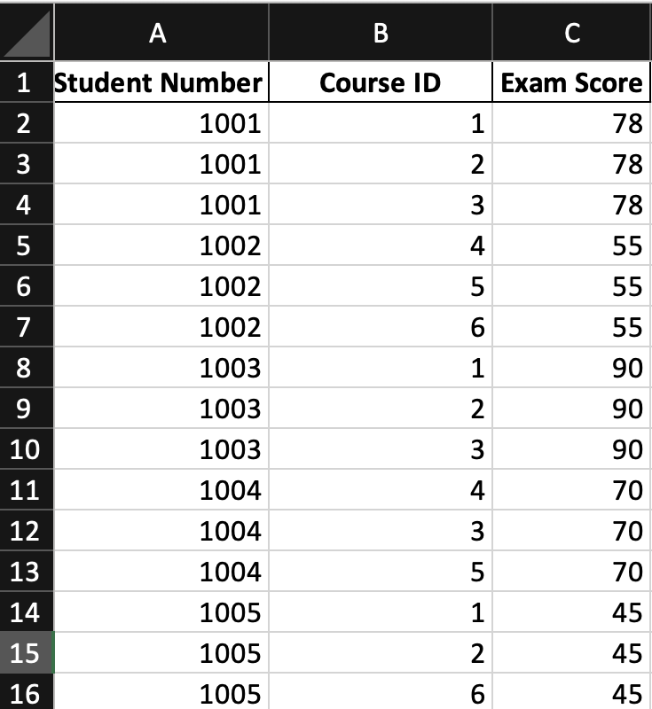

## **Data Build Task**

